## horizontal line



Cafe

CMS

**───**

# 

# Table Content

Installation

Login

Visitor Management

Training Management

Pos Management

Inventory Management

Reporting Management

Settings

Leave Management

Control Bot

# 

# 

# Installation

### **Check whether IIS, nodejs and mysql installed on the server.**

We can check this in start menu by searching,

* iis (or) inetmgr
* Mysql
* Nodejs

If it is not installed, we need to download the softwares and install. For IIS we need to just enable it .

**Enabling IIS :**

go to control panel-> Turn windows features on or off -> Server manager will be prompted. In Add roles and features wizard,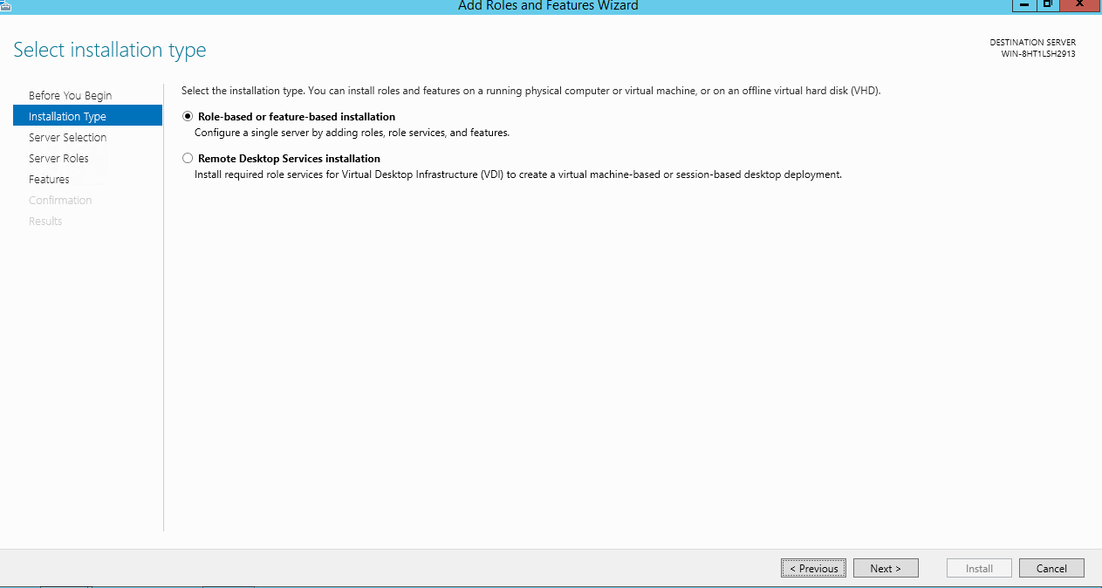

Select the below features and its child features,

* .NET framework 3.5 features
* .NET framework 4.5 features
* Remote server administration tools
* SMTP server
* Windows process activation service

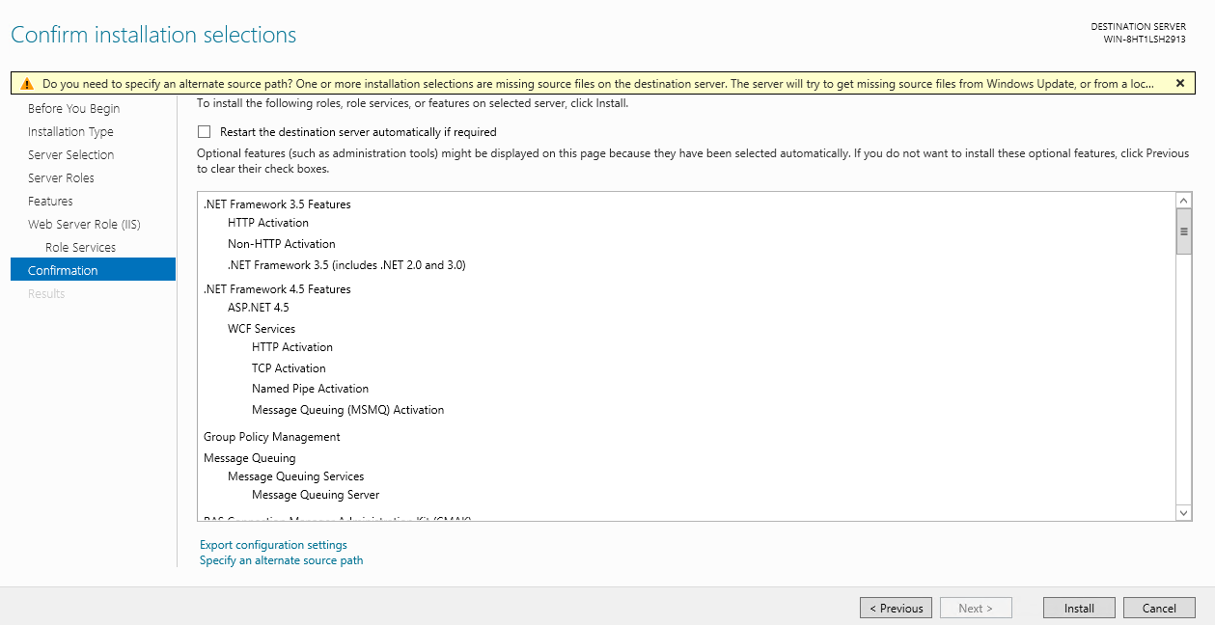

Final step of installation should be like this.

**Installing Mysql :**

Download Mysql 5.7 using the link <https://dev.mysql.com/downloads/windows/installer/5.7.html>

Select ‘Windows (x86, 32-bit), MSI Installer with 503.8M’ and select ‘No thanks, just start my download.’ in next page. It will start downloading the software.

Once it is downloaded, install it.

Set the root user password now. We need to share the db name and credentials to the developer, so that developer can use it in the code for db connection.

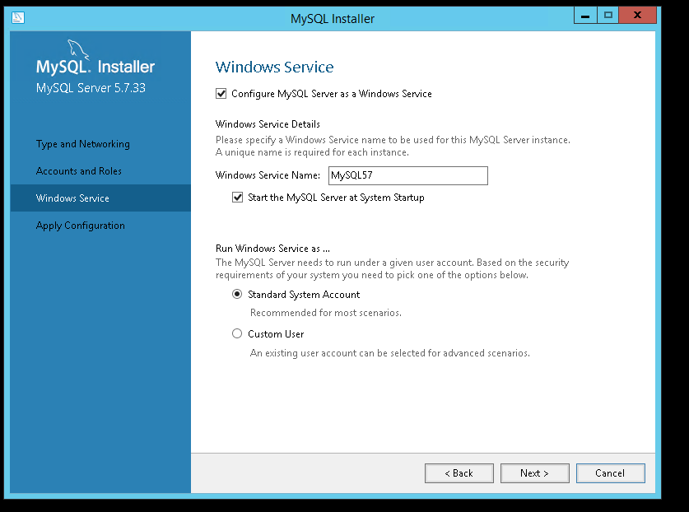

Installation is same like mysql installation. After installation mysql work bench will be launched. We need to create new connection and login with the root credentials.

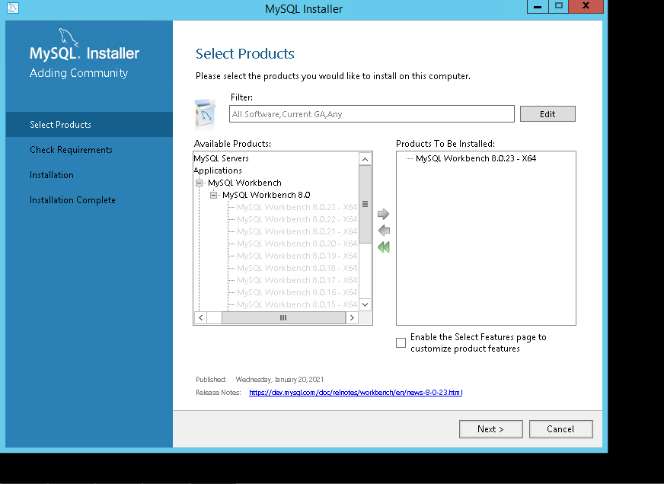

**Installing Node js 12 :**

Download the Node js 12 software from this link, <https://nodejs.org/dist/latest-v12.x/node-v12.21.0-x64.msi>

Install it, with default values in wizard.

We can confirm whether it is installed by searching in start menu.

Executel below commands in command prompt which will install angular, typescript and sails

* npm install -g @angular/cli
* npm i typescript
* npm install -g sails

Create “cms” folder in this path “C:\inetpub\wwwroot\”

Create a folder “cms frontend” inside cms and “dist” folder in cms frontend

Deploy the frontend build (webe folder) given by the developers, inside the “dest” folder .

Create a folder “agile_backend” inside cms folder. Deploy the backend build given by the developer. Folder structure and backend files should be like in below picture,

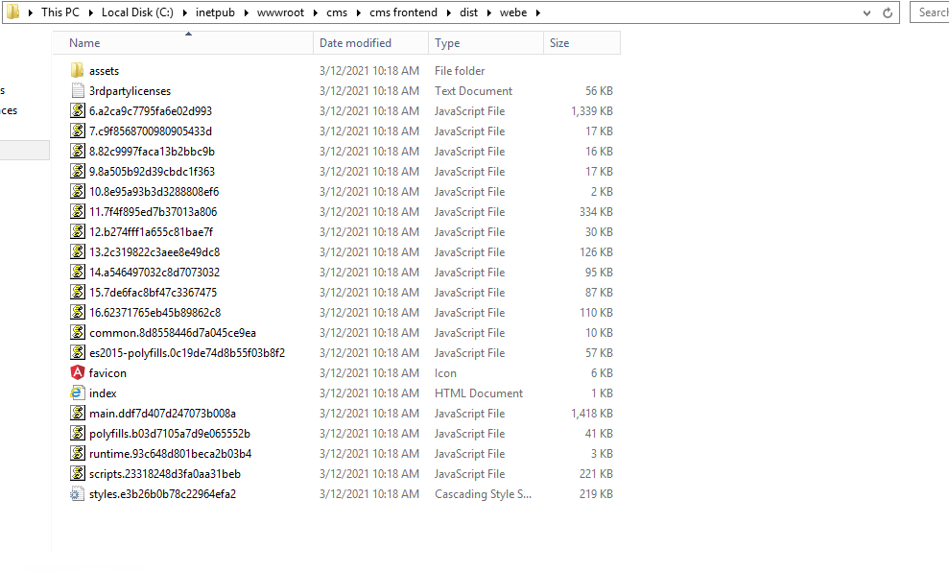

Creating db and deploy sql files in mysql. Open mysql workbench and connect to the mysql server with the root credentials we created.

Create a new schema (db) with the name “agile_production” and click on apply.

Once schema is created select Server -> Data import .

Select option “import from self contained file”. Browse the sql file which is given by developer.

Default target schema should be the schema (db) name “agile_production” which we created earlier and click on start import.

(refer below picture)

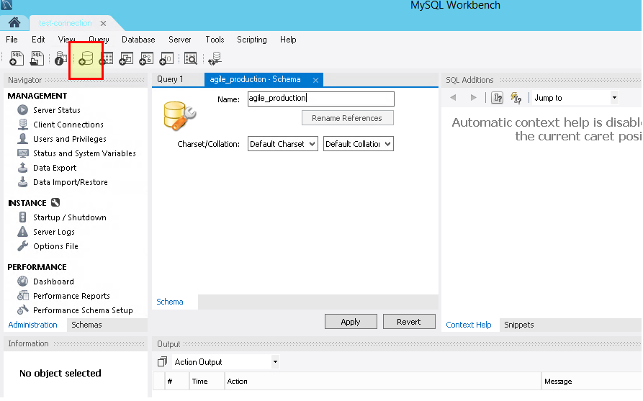

Once import completed we will get “1 of 1 imported”.

Create a new site with the name “cms”, application pools “cms”, physical path should be “C:\inetpub\wwwroot\cms\cms frontend\dist\webe” and port is 81.

Open the chrome browser and hit the <http://localhost:81> url, we should see the

page like below

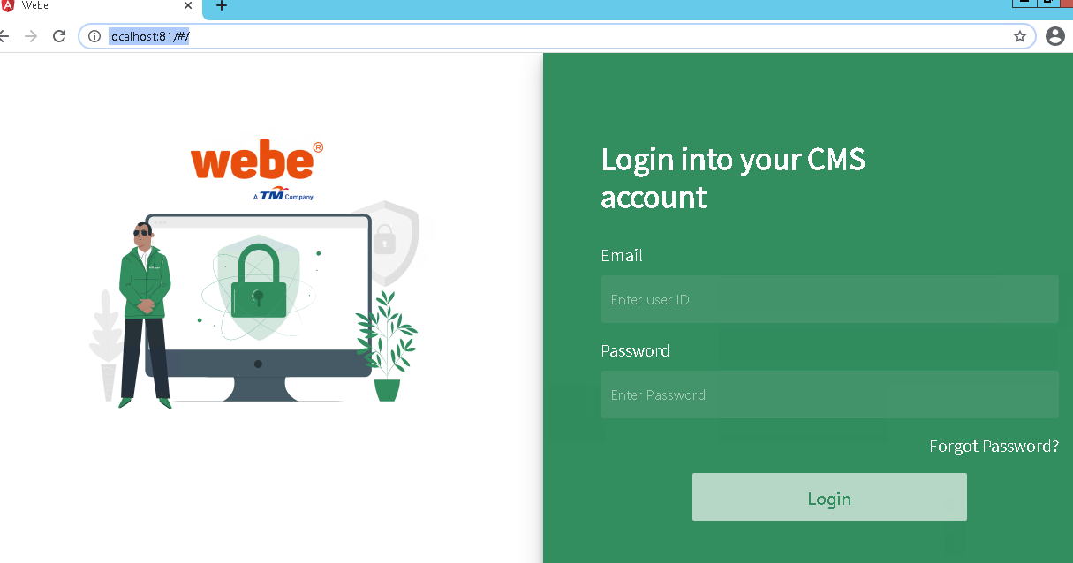

# Login

Before entering the cafe world you might enter with the proper email id and password. Credentials get success then we redirected to the dashboard.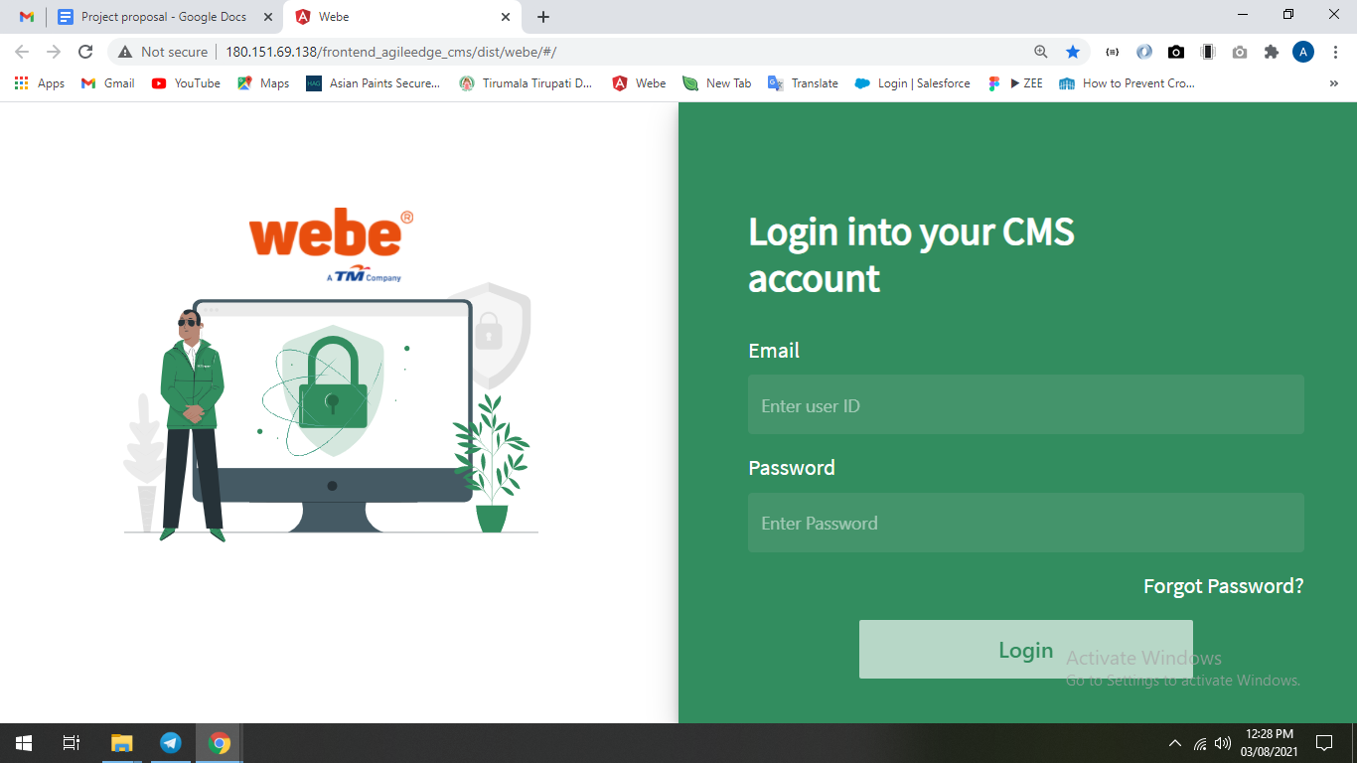

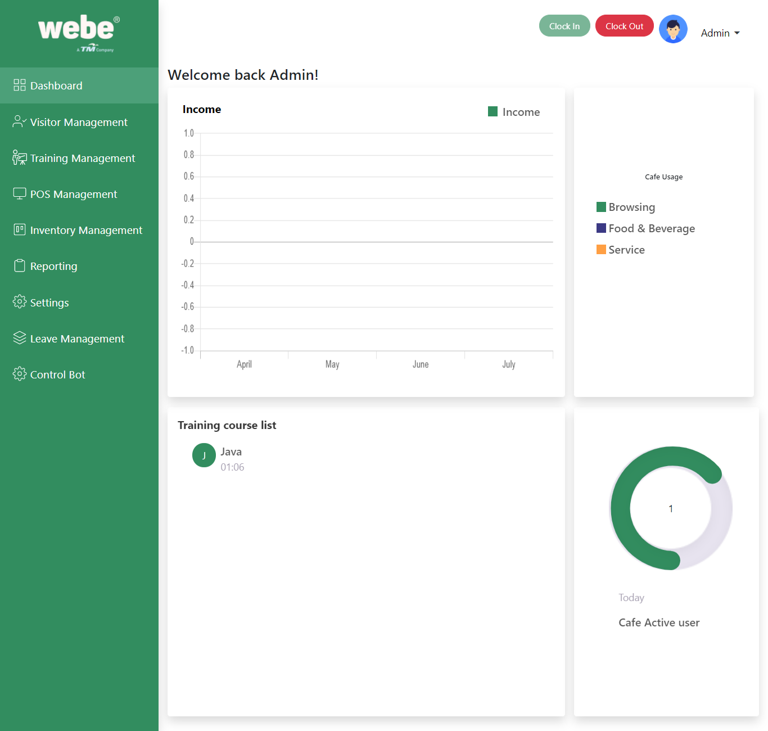

After successfully logged in, the user will be monitored the time login to activity of the user.

The clockIn button will be displayed. When the user wants to logout, the user has to click on the clock out button to close the session.

# Visitor Management

Visitor Details are handled in this section. We can edit the visitor details by clicking on the three dot button.

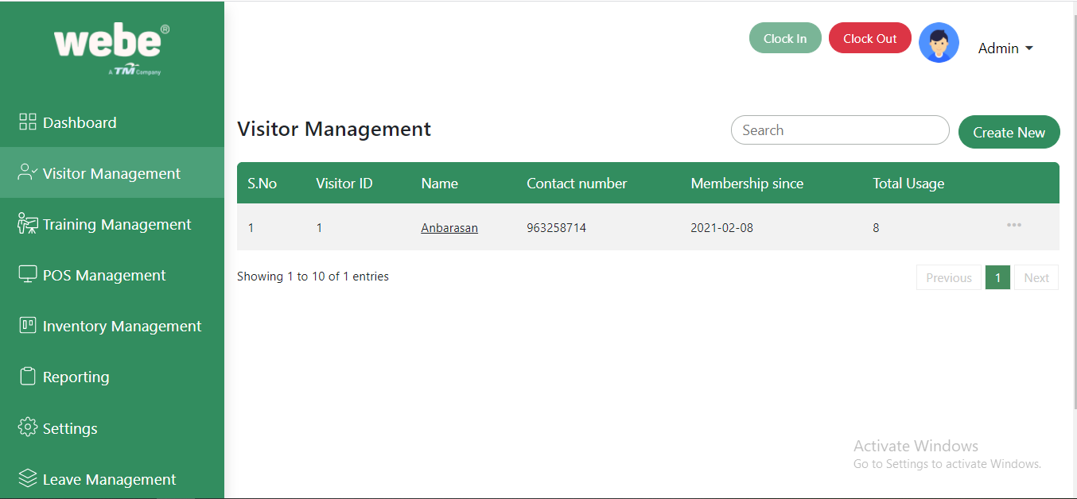

View visitor information by clicking on the name column in the table.

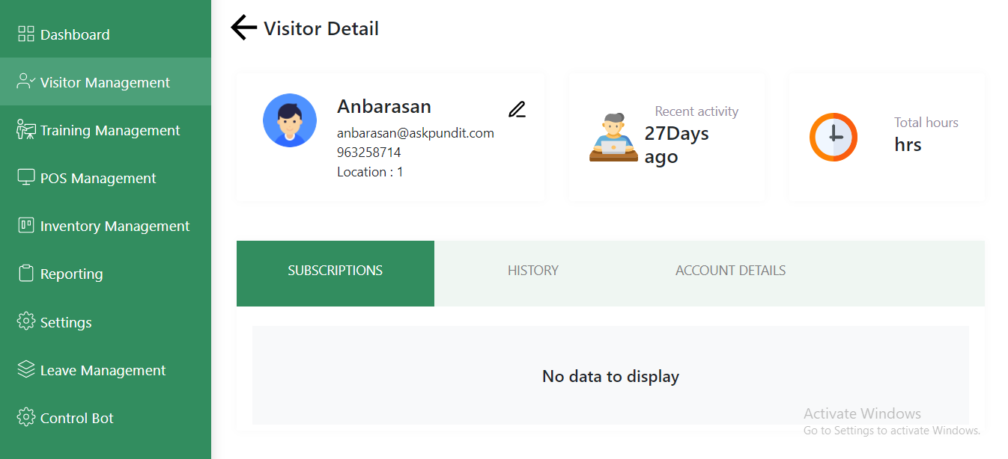

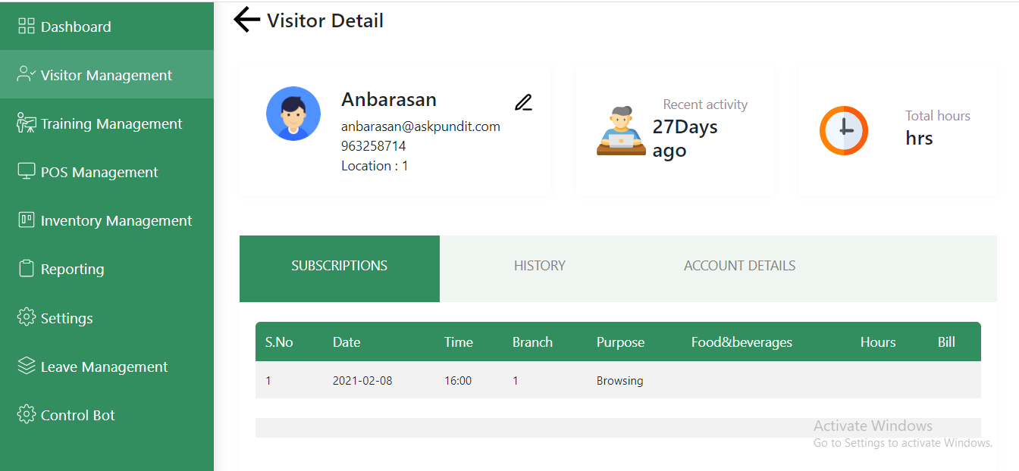

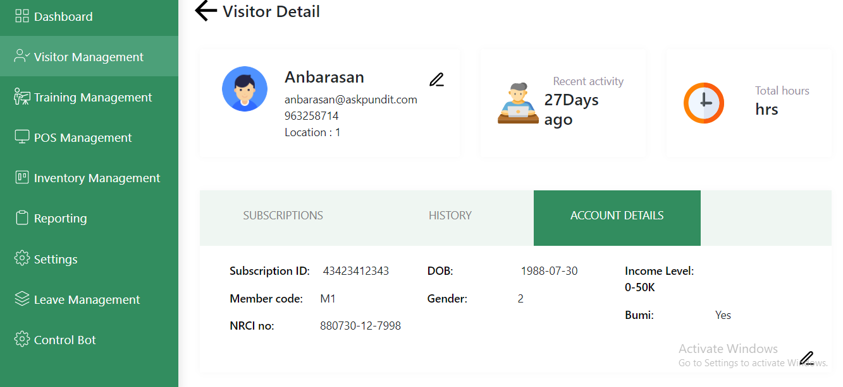

We can create a new visitor by hitting Create New button

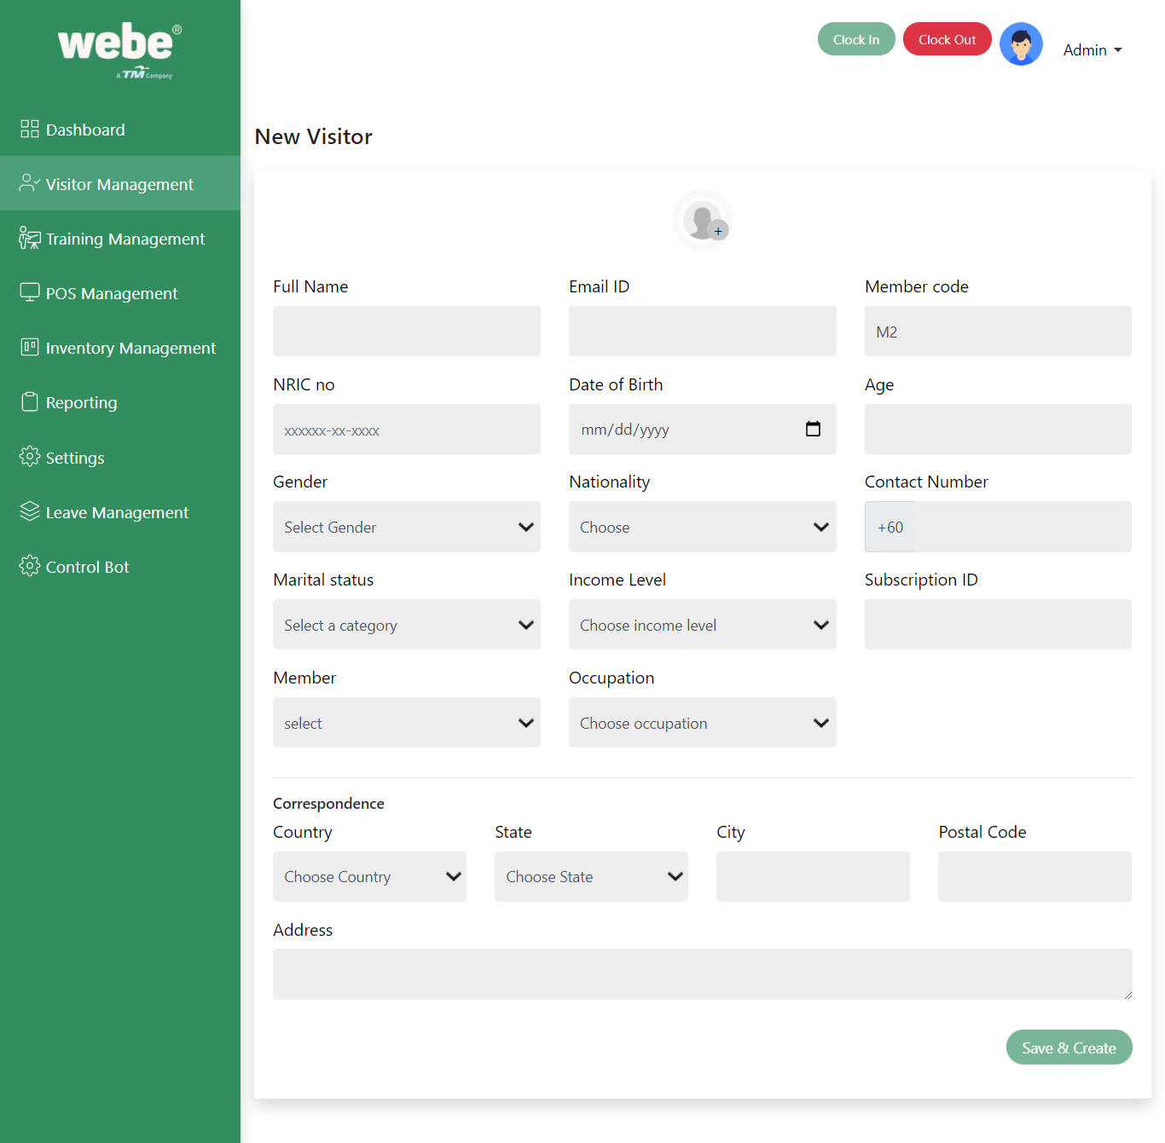

Edit the details by clicking on the three dot button in the datatable page.

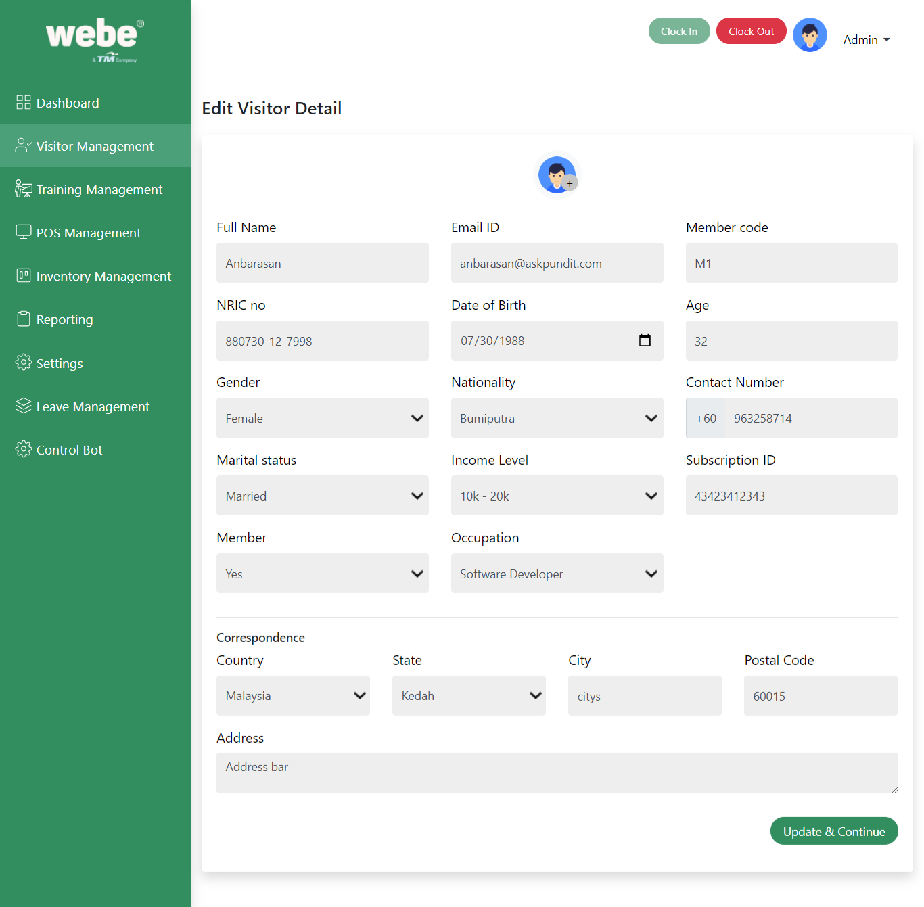

# Training Management

We can create a new course for the training in this section. We are adding the members into course by clicking on the Add new button.

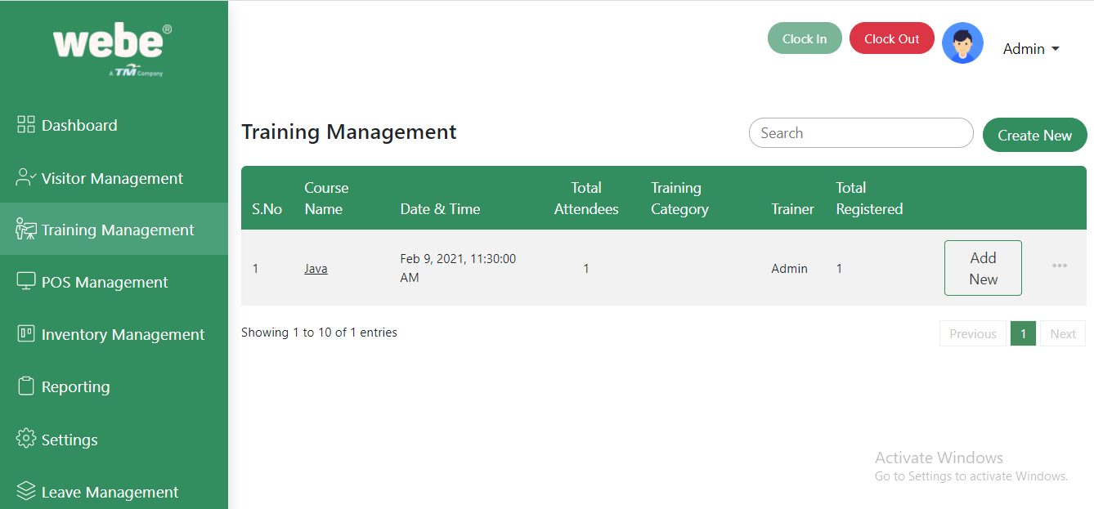

By click on the Create New button we can create a new course training.

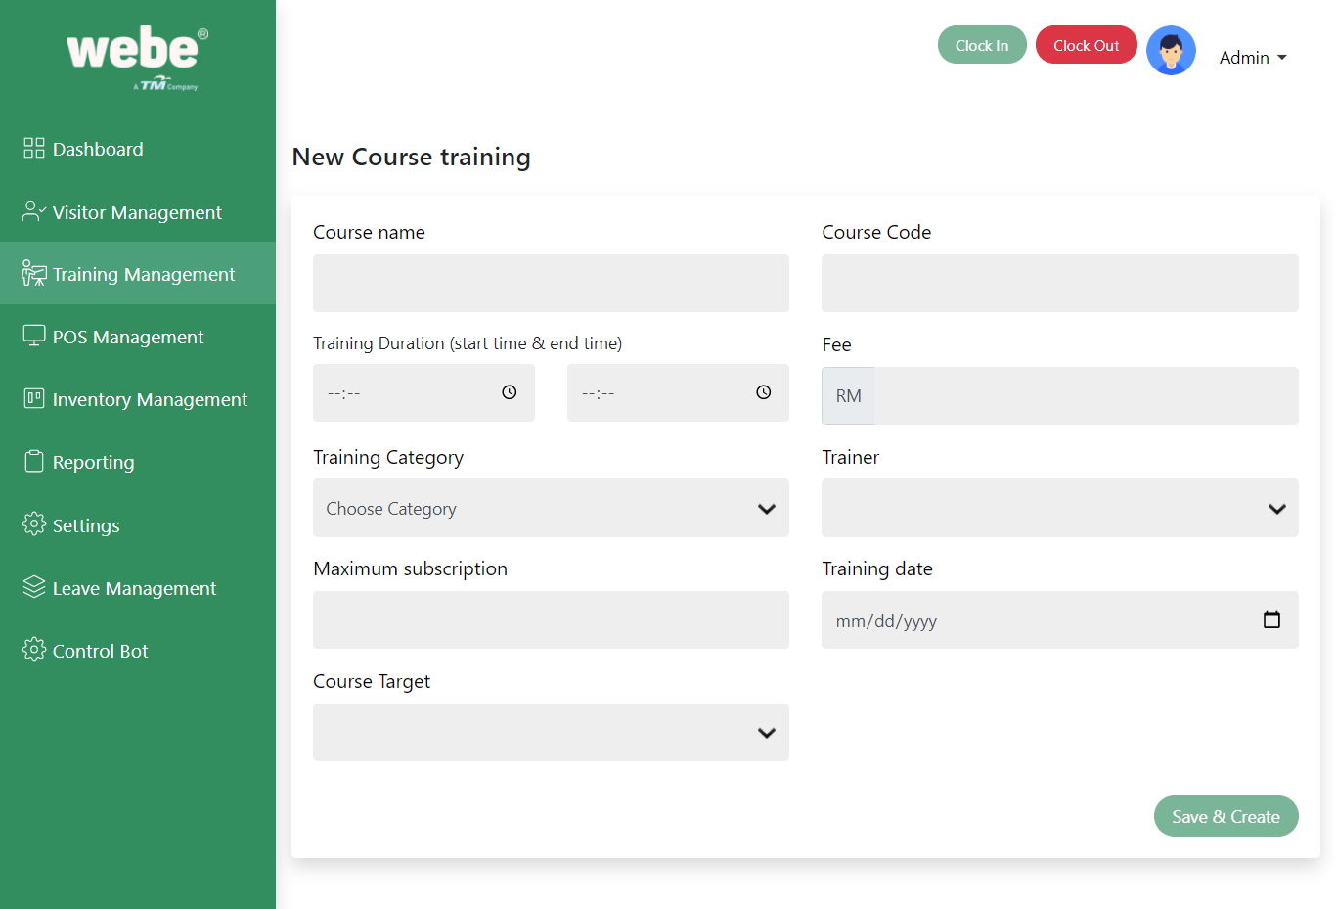

Fill all the above mandatory fields and hit submit button and then will be redirected to the main page. In there we can see the created details.

We can add new members into the course by clicking on the add new button in the table column.

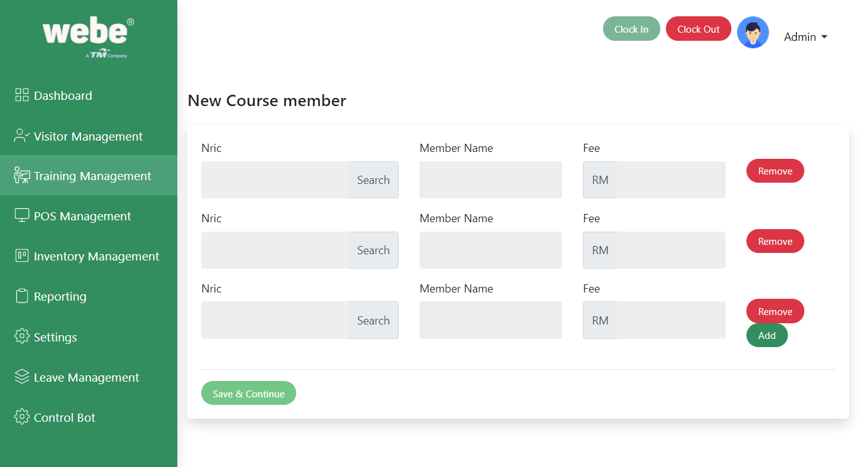

Find the registered visitor by their Nric number. There is an option to add multiple visitors into the same course at the same time. Add all the details and then click on the save and continue button.

By clicking on the course name we can see the details of the course.

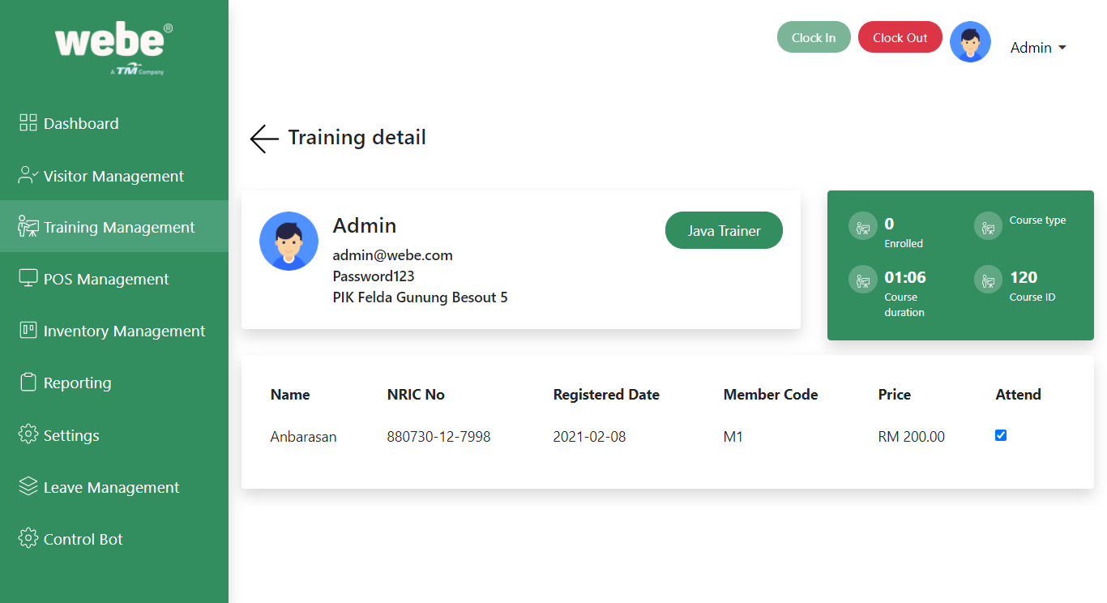After adding a member into the course whether the member is attending a course or not we can monitor by clicking on the attend check box.

# Pos Management

In this Pos Management we can assign a pc for the visitor to browse or the training. There are a few controls to make the visitor to more flexible.

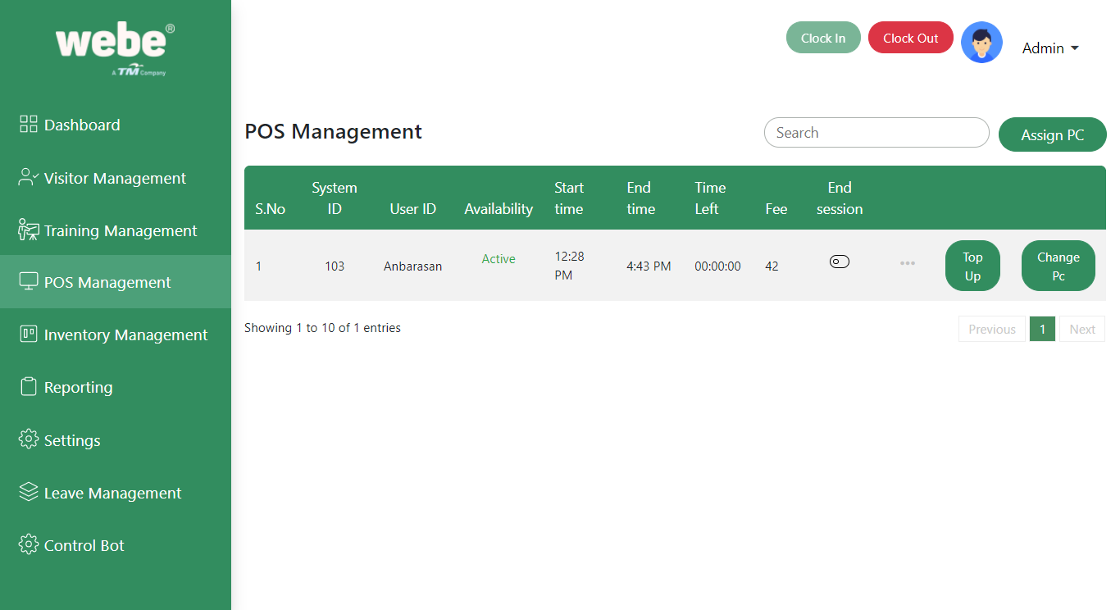

## Assign Pc

## 

When you click on the Assign PC button, the above window will be displayed. In this window you can see the available pc list under the select pc. You have to choose the PC by clicking on the pc number.

Then have to search the registered visitor by using NRIC number. If it's a valid number then the Assign to textbox automatically filles.

And then select duration in hours and minutes to access. There is a purpose to are we going to do the browsing or going to take a course. Fill the form and press on the create button.

## Top up

When we click on the top up button We can top up the browsing or training hours to continue browsing. When we add the top up it will be added into the existing hours.

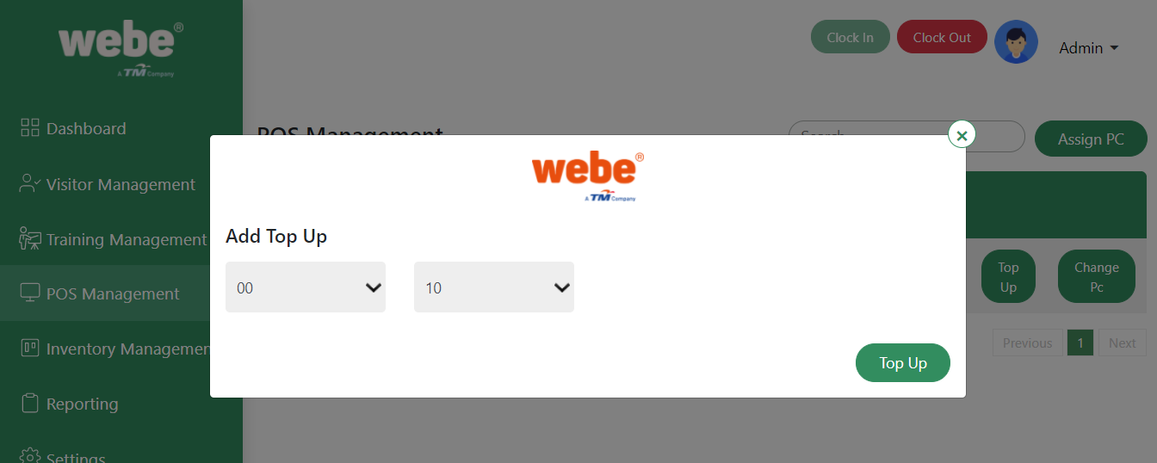

## Change Pc

If we face any problem with the PC we can switch into another pc by clicking on the change pc button. We can use new pc by selecting the pc number and press change pc

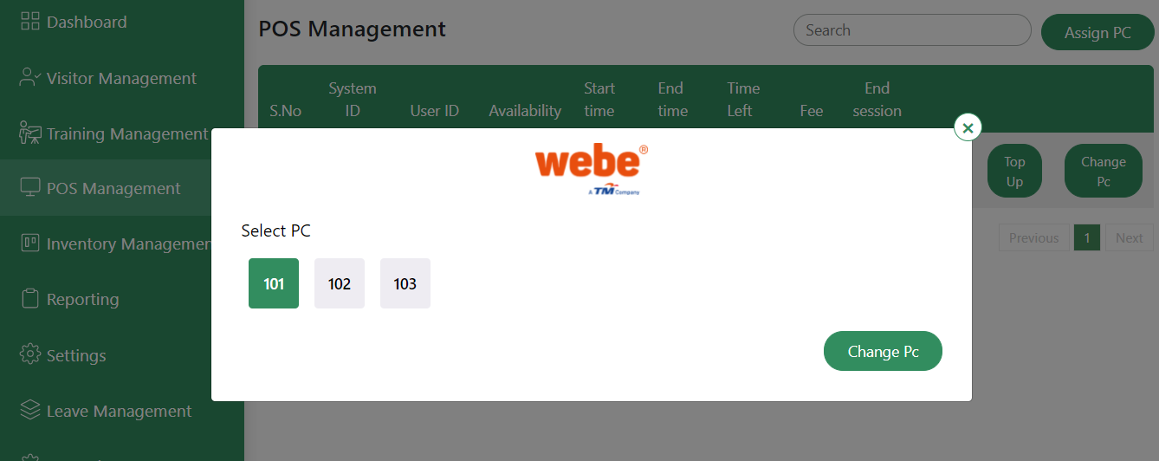

## End session

We can close the browsing by click on the End session button.

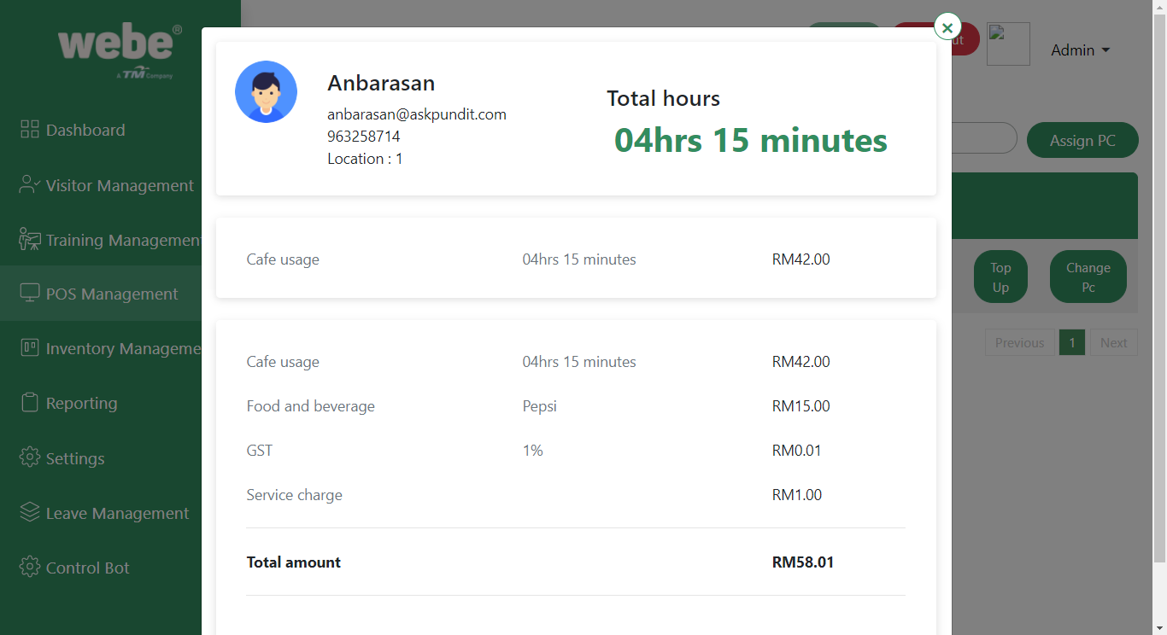

# Inventory Management

Inventory Management contains all the dropdown filed details by adding new items into the inventory. Using inventory Management we can add, edit and delete the dropdown information and pos management food and service details.

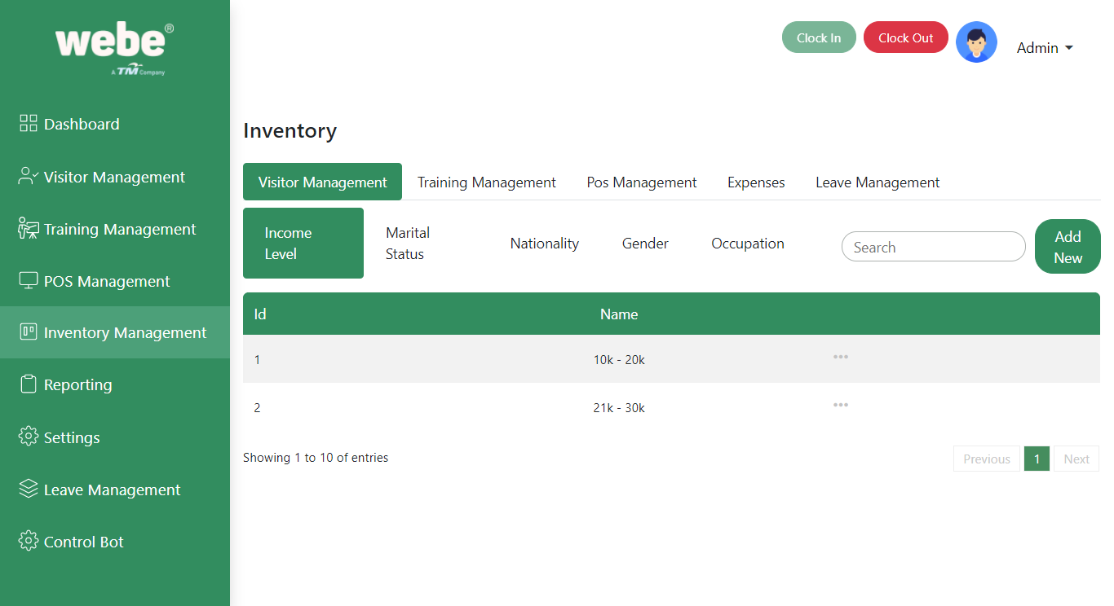

For example : Above Image is selected in Visitor Management. Below of the listed items are the information for the Visitor management dropdown items.

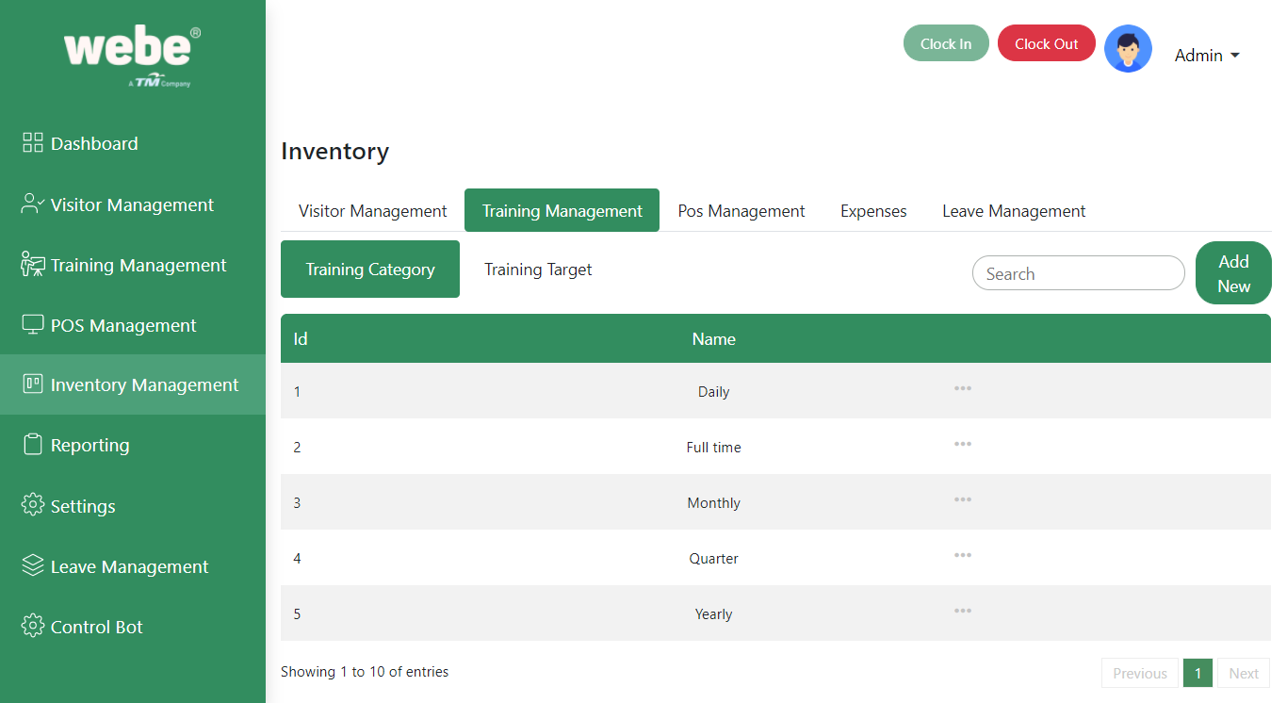

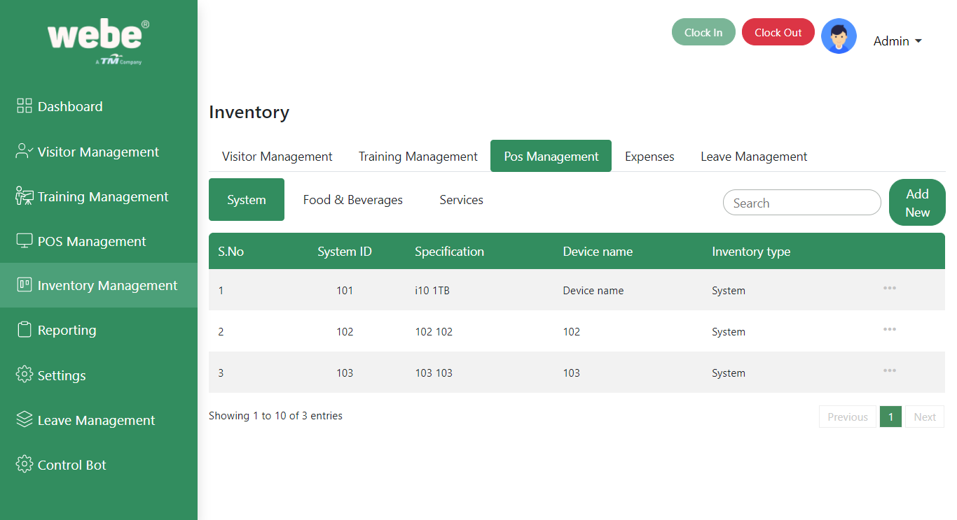

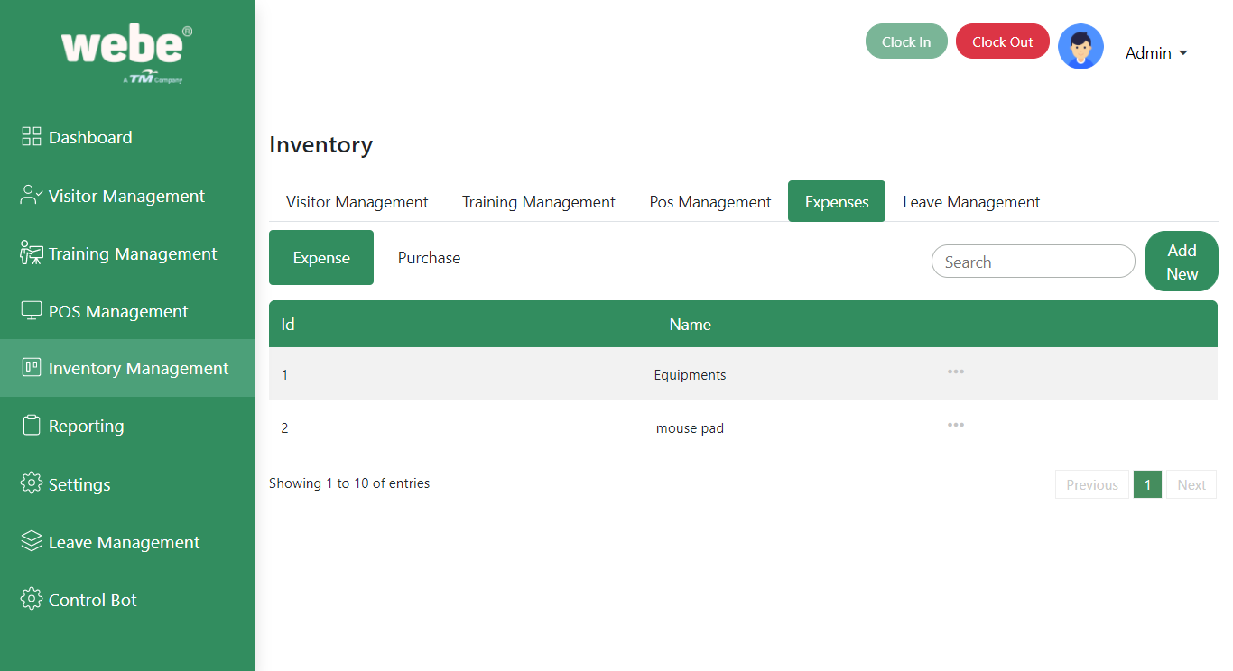

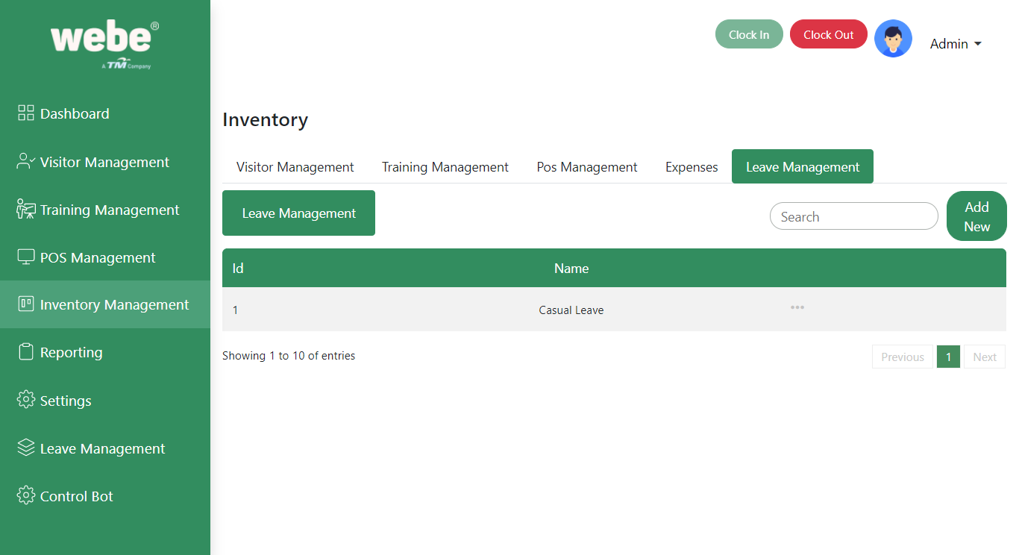

# Report Management

In report management we can generate the reports for the mentioned items under the summary dropdown. We can filter the items based on the period , from date, to date.

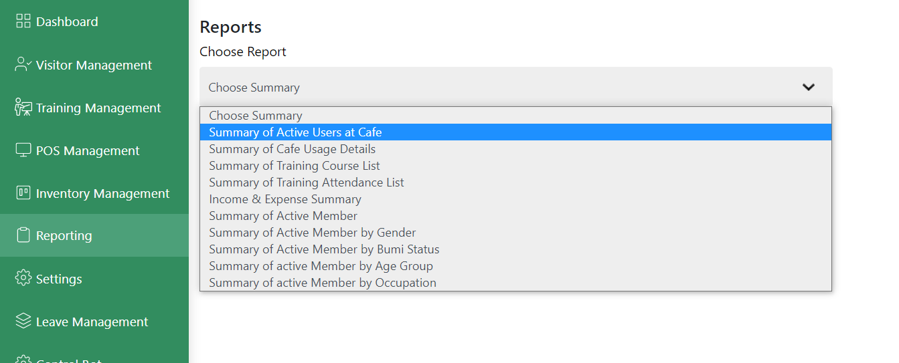

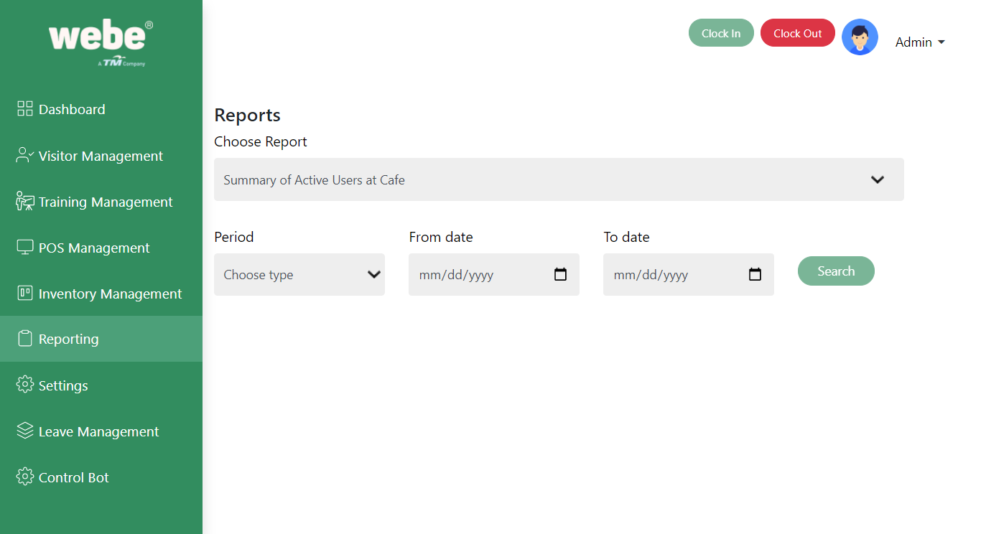

# Settings

We can configure the GST/SST, Member, Non-Member, Membership Registration settings in the settings section.

## GST/ SST

Configure the GST/SST by clicking on the edit button and then save.

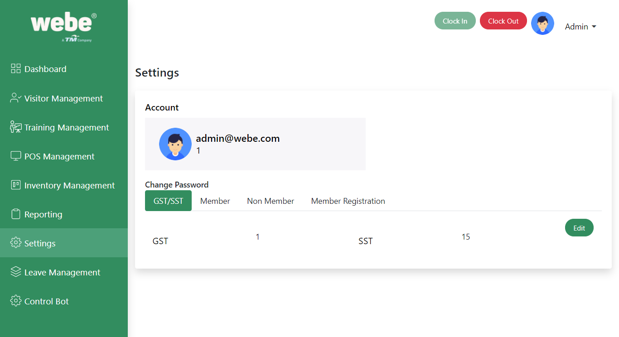

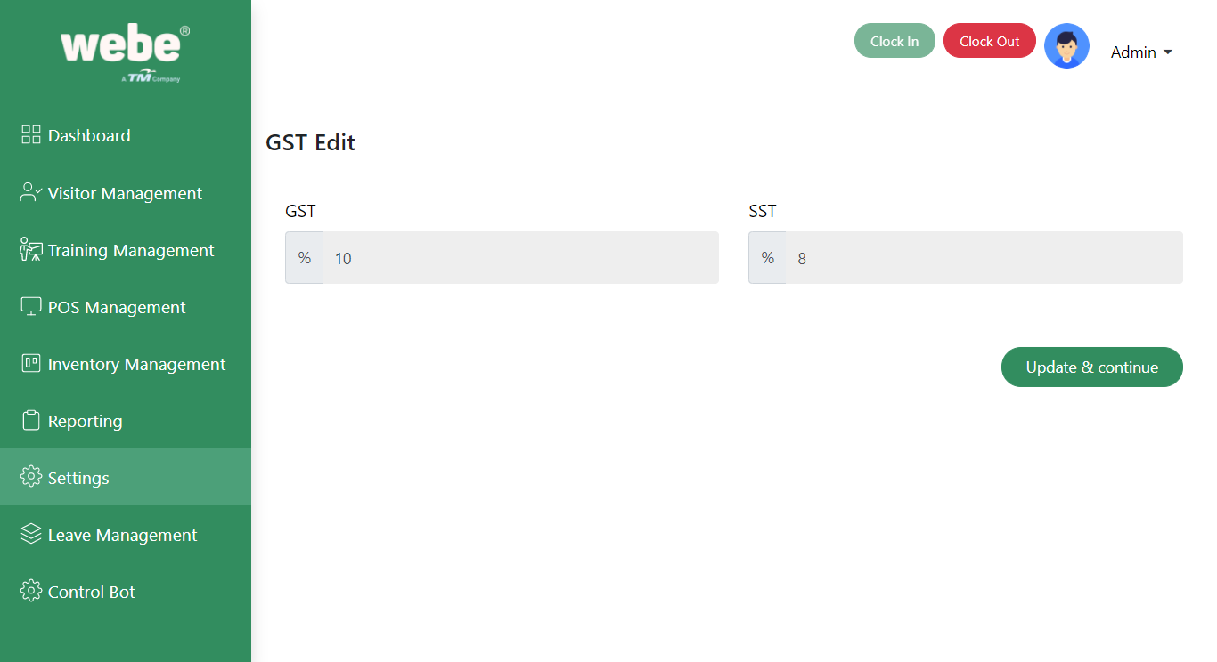

## Member

Configure the Membership details by clicking on the Edit button.

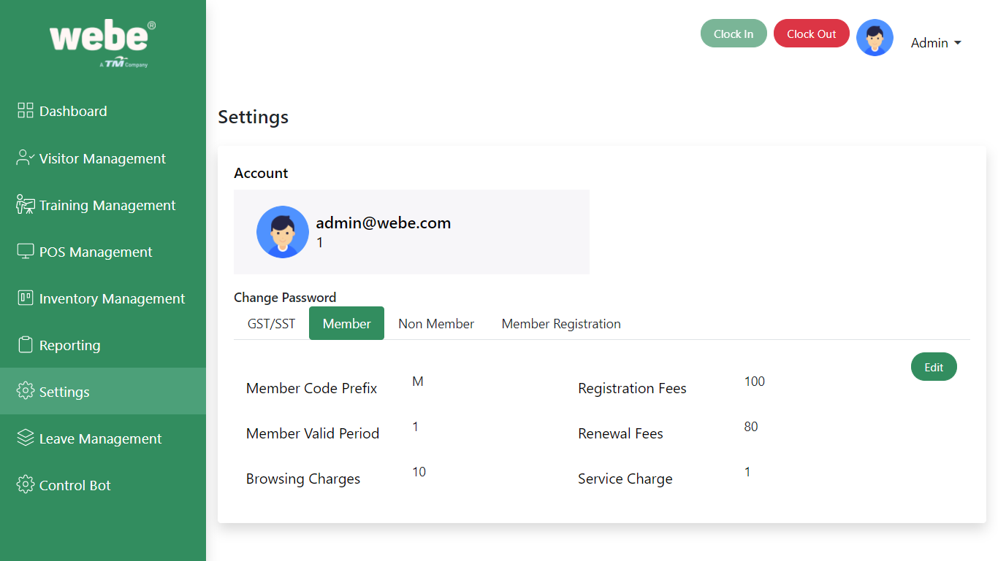

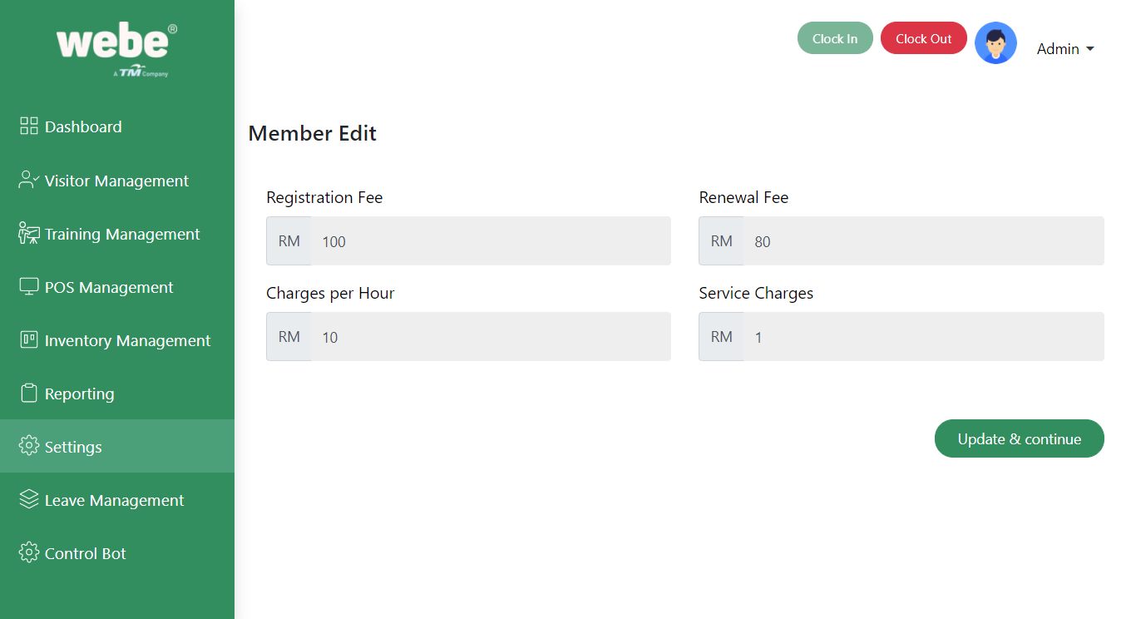

## 

## 

## Non Member

Configure the NonMember details by clicking on the edit button.

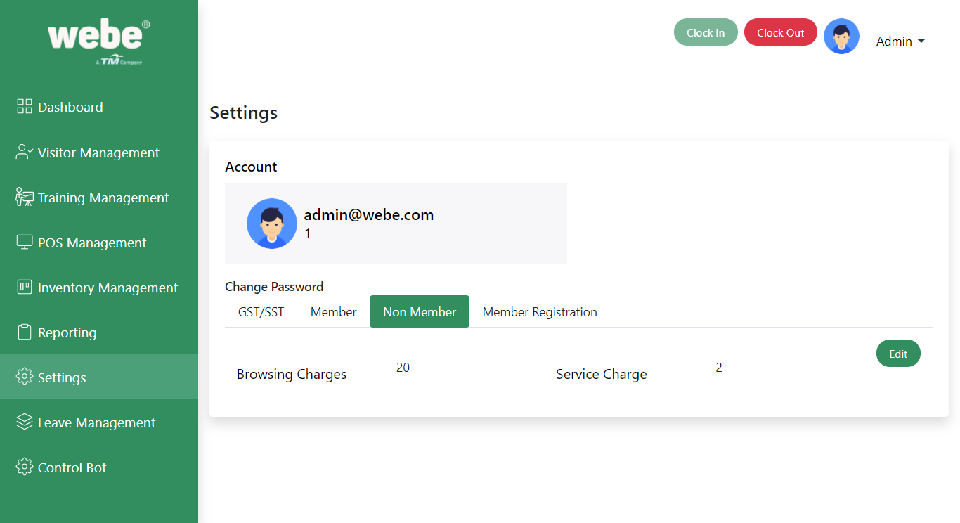

## Member Registration

We can register and Renew the membership by clicking on the Manage button.

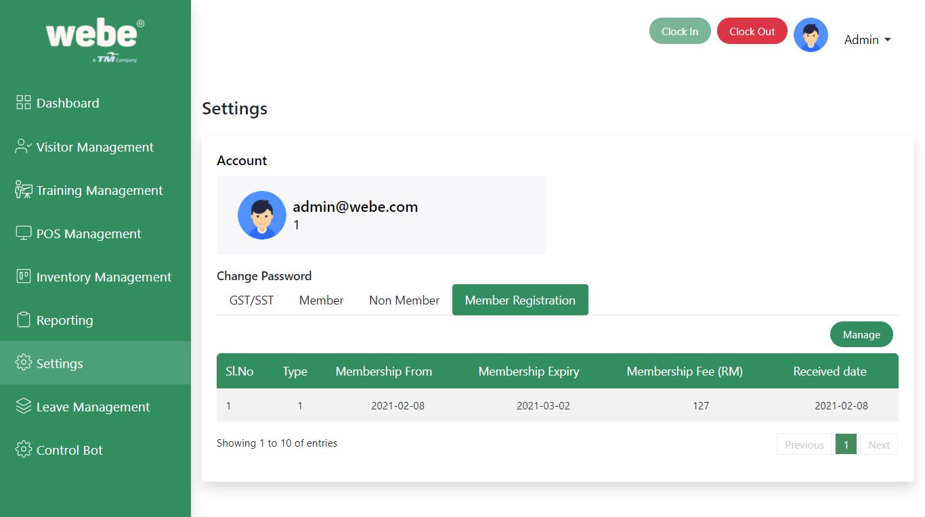

There is a type dropdown to choose the membership is going to be Renewal or Create.

Have to enter the details based on the type. Once filled all the details then have to hit the update button. Then the button will be redirected to the next tab. In the window we can see the details for registration and renewal items.

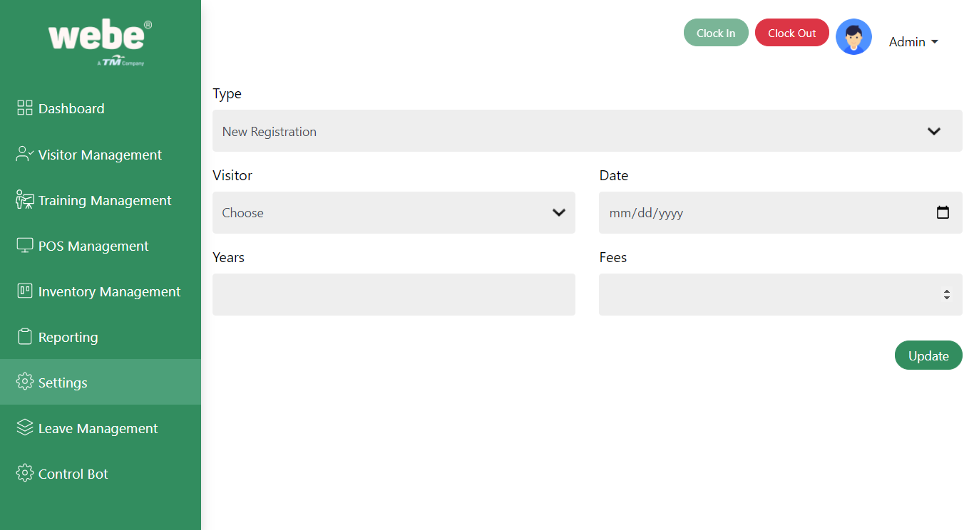

## Renewal

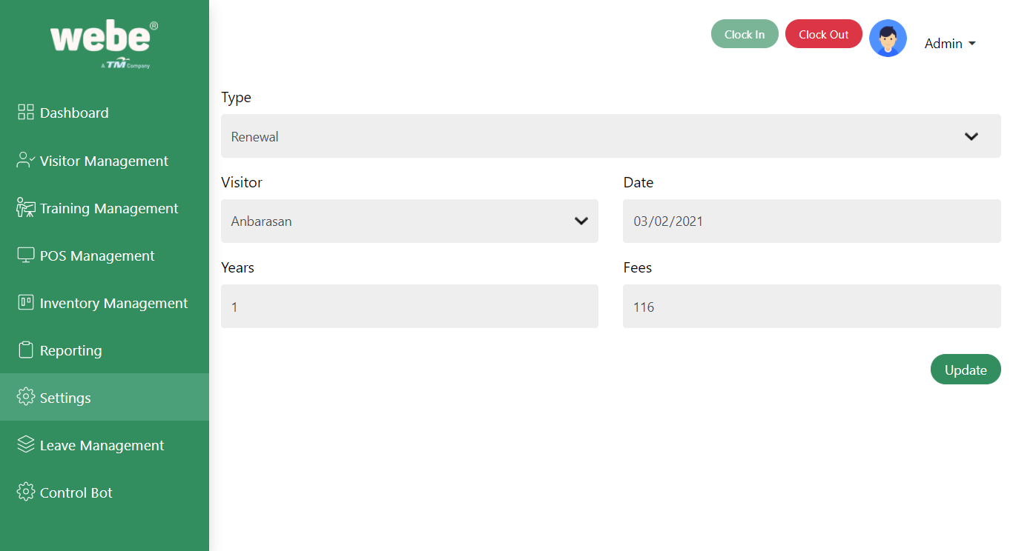

# Leave Management

The employee can apply for the leave in this section. Apply leave by clicking the Apply leave button.

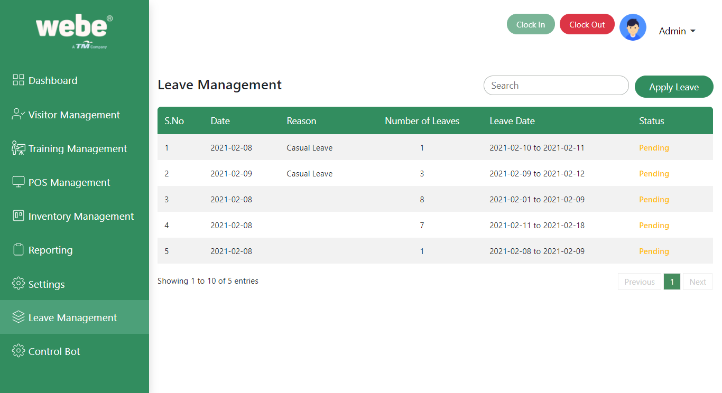

Select the start date and end date to apply the leave and select the Reason dropdown. That will be the leave which we created in the inventory management.

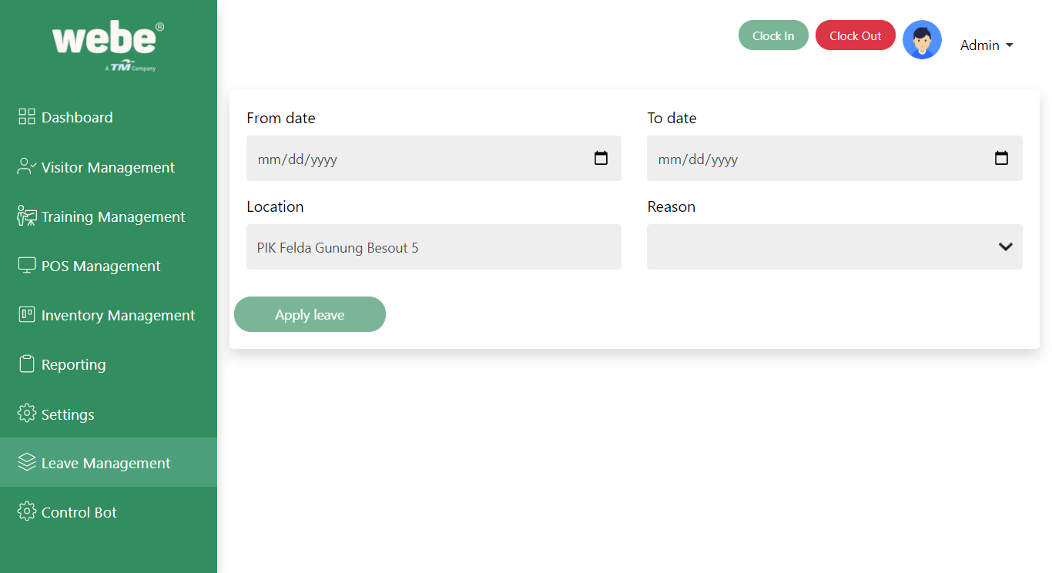

# Control Bot

Can we access the visitor pc by using the control bot panel. Have to select the PC then using a few controls to do the needs. Like send a message, Lock the pc, shut down, restart, Ping pc.

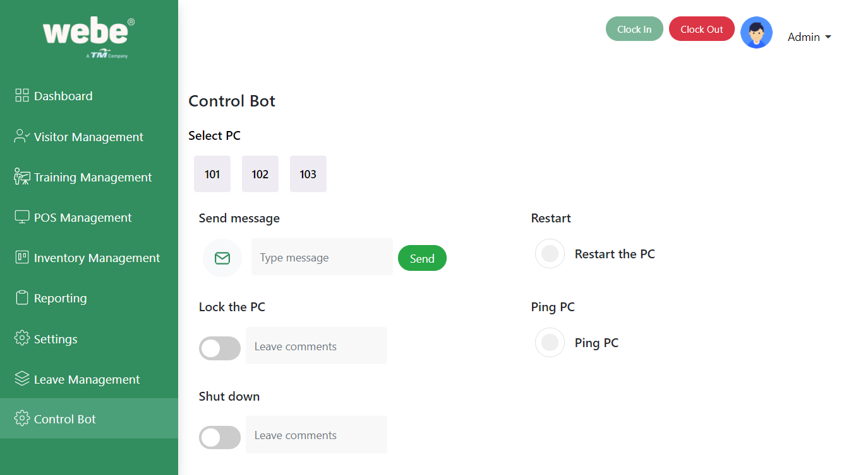

Finally when the employee closes the day, they have to click on the clock out button. Here we can monitor the clock in and clock out details.

# Pre-requisites

CMS-Outlet must be installed on your local system(s) along with the control bot.

Remote client X app running on background.

# Instructions

Login to CMS-Outlet using another system and go to the menu Inventory Management - POS Management - system. Click Add New and fill all the fields with data obtained. (i.e)Configuration details like device name, IP address, system ID, type. Make sure you are entering the correct IP address. Now the configuration part is over. Then go to the menu Control Bot.Select the PC which you have already added on Inventory management.

# Control Bot - Lock PC

If you want to lock the selected PC, click on the “Lock the PC” toggle and enter the reason in the “Leave comments” field. But it’s an optional field. And check if the selected PC was locked or not.

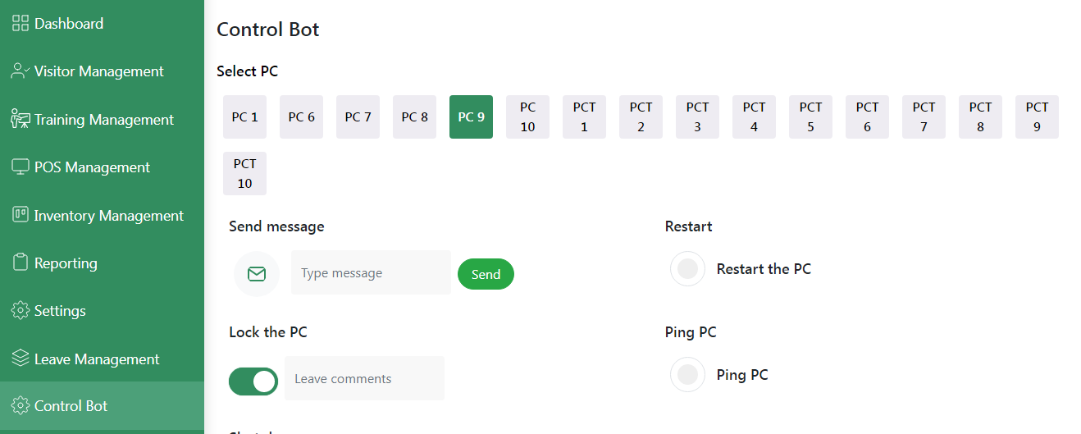

You are able to see the lock screen of the PC after successful attempt of LOCK PC action in the control bot.

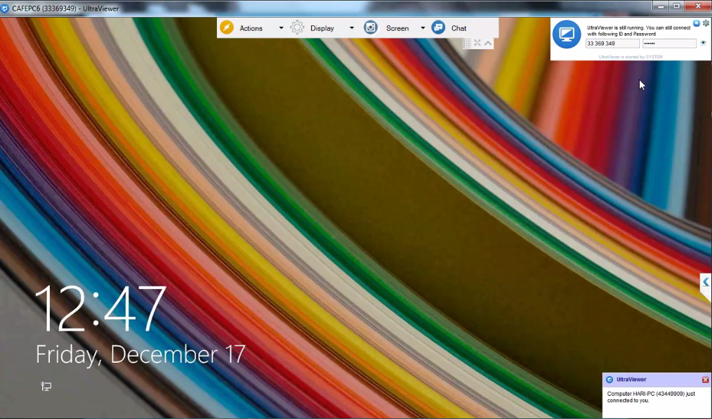

# Control Bot - Ping PC

If you want to ping the selected PC, click on the “Ping PC” radio button. And check if the selected PC was pinged or not.

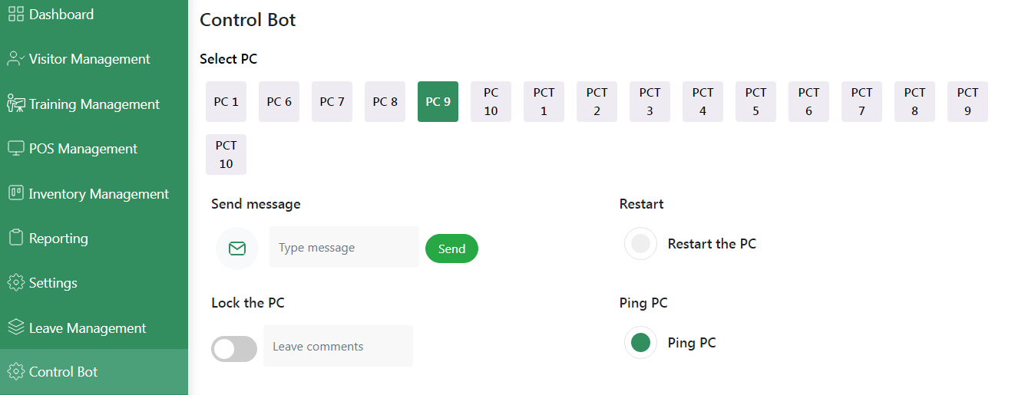

# Control Bot - Shut Down PC

If you want to shut down the selected PC, click on the “Shutdown” toggle and enter the reason in the “Leave comments” field. But it’s an optional field. And check if the selected PC was shutdown or not

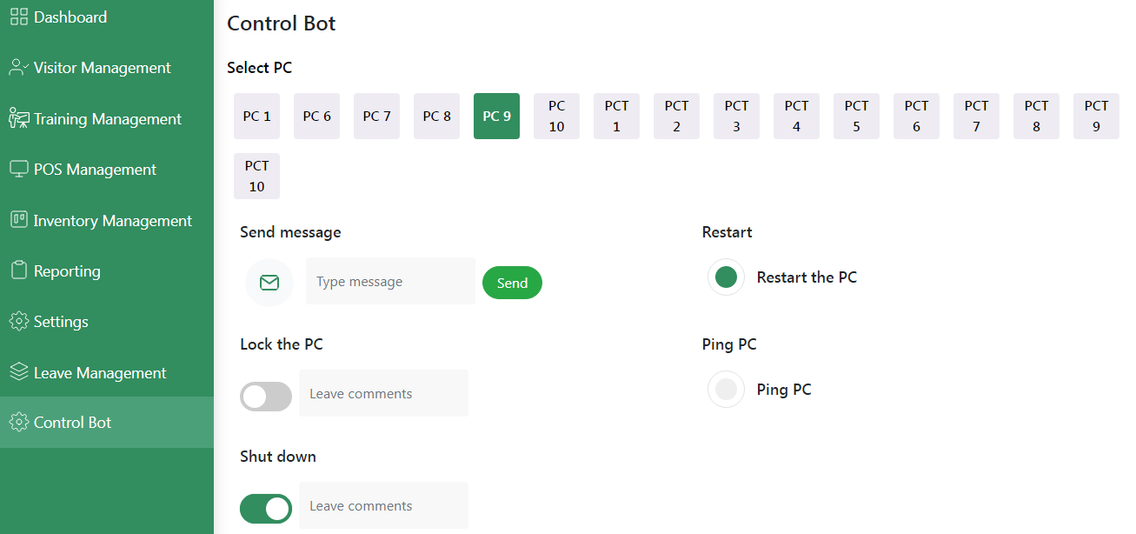

# Control Bot - Restart PC

If you want to restart the selected PC, click on the “Restart the PC” radio button. And check if the selected PC automatically restarts or not.

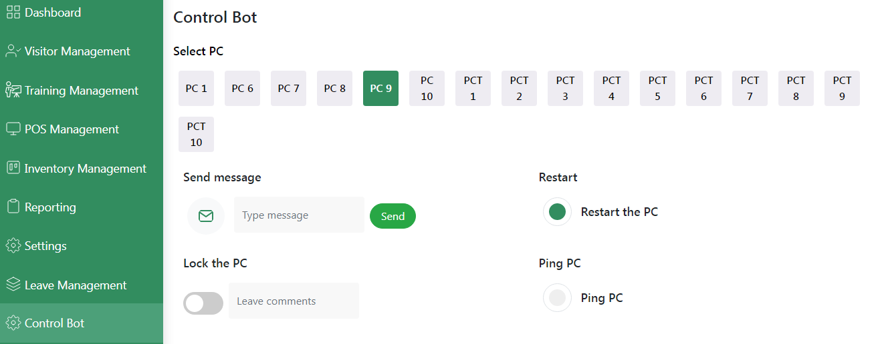

# Control Bot - Send Message

We can send message by Entering message in the input box and then click send user can able to see message on their PC while remoteclientX app running on background.

